1. **SYNOPSIS**

**1.1 INTRODUCTION TO THE PHP FRAMEWORK**

**FRONT END: PHP**

PHP development began in 1995 when Rasmus Lerdorf wrote several Common Gateway Interface (CGI) programs in C, which he used to maintain his personal homepage. He extended them to work with web forms and to communicate with databases, and called this implementation "Personal Home Page/Forms Interpreter" or PHP/FI.

PHP/FI could be used to build simple, dynamic web applications. To accelerate bug reporting and improve the code, Lerdorf initially announced the release of PHP/FI as "Personal Home Page Tools (PHP Tools) version 1.0" on the Usenet discussion group comp. infosystems .www.authoring.cgi on June 8, 1995. This release already had the basic functionality that PHP has as of 2013. This included Perl-like variables, form handling, and the ability to embed HTML. The [syntax](https://en.wikipedia.org/wiki/Syntax) resembled that of Perl but was simpler, more limited and less consistent.

Early PHP was not intended to be a new programming language, and grew organically, with Lerdorf noting in retrospect: "I don’t know how to stop it, there was never any intent to write a programming language […] I have absolutely no idea how to write a programming language, I just kept adding the next logical step on the way. A development team began to form and, after months of work and [beta](https://en.wikipedia.org/wiki/Beta_development_stage) testing, officially released PHP/FI 2 in November 1997.

The fact that PHP was not originally designed but instead was developed organically has led to inconsistent naming of functions and inconsistent ordering of their parameters. In some cases, the function names were chosen to match the lower-level libraries which PHP was "wrapping", while in some very early versions of PHP the length of the function names was used internally as a [hash function](https://en.wikipedia.org/wiki/Hash_function), so names were chosen to improve the distribution of hash values

**History of PHP:**

**PHP 3 and PHP 4**

[Zeev Suraski](https://en.wikipedia.org/wiki/Zeev_Suraski) and [Andi Gutmans](https://en.wikipedia.org/wiki/Andi_Gutmans" \o "Andi Gutmans) rewrote the [parser](https://en.wikipedia.org/wiki/Parser) in 1997 and formed the base of PHP 3, changing the language's name to the[recursive acronym](https://en.wikipedia.org/wiki/Recursive_acronym) PHP: Hypertext Preprocessor. Afterwards, public testing of PHP 3 began, and the official launch came in June 1998. Suraski and Gutmans then started a new [rewrite](https://en.wikipedia.org/wiki/Rewrite_(programming)) of PHP's core, producing the [Zend Engine](https://en.wikipedia.org/wiki/Zend_Engine" \o "Zend Engine) in 1999. They also founded [Zend Technologies](https://en.wikipedia.org/wiki/Zend_Technologies" \o "Zend Technologies) in [Ramat Gan](https://en.wikipedia.org/wiki/Ramat_Gan), Israel.

On May 22, 2000, PHP 4, powered by the Zend Engine 1.0, was released. As of August 2008 this branch reached version 4.4.9. PHP 4 is no longer under development nor will any security updates be released.

**PHP 5**

On July 14, 2004, PHP 5 was released, powered by the new Zend Engine II. PHP 5 included new features such as improved support for [object-oriented programming](https://en.wikipedia.org/wiki/Object-oriented_programming), the PHP Data Objects (PDO) extension (which defines a lightweight and consistent interface for accessing databases), and numerous performance enhancements. In 2008 PHP 5 became the only stable version under development. [Late static binding](https://en.wikipedia.org/wiki/Late_static_binding) had been missing from PHP and was added in version 5.3.

Many high-profile open-source projects ceased to support PHP 4 in new code as of February 5, 2008, because of the GoPHP5 initiative, provided by a consortium of PHP developers promoting the transition from PHP 4 to PHP 5.

Over time, PHP interpreters became available on most existing [32-bit](https://en.wikipedia.org/wiki/32-bit) and [64-bit](https://en.wikipedia.org/wiki/64-bit) operating systems, either by building them from the PHP source code, or by using pre-built binaries. For the PHP versions 5.3 and 5.4, the only available [Microsoft Windows](https://en.wikipedia.org/wiki/Microsoft_Windows) binary distributions were 32-bit [x86](https://en.wikipedia.org/wiki/X86) builds, requiring Windows 32-bit compatibility mode while using [Internet Information Services](https://en.wikipedia.org/wiki/Internet_Information_Services) (IIS) on a 64-bit Windows platform. PHP version 5.5 made the 64-bit [x86-64](https://en.wikipedia.org/wiki/X86-64) builds available for Microsoft Windows.

**PHP 6 and Unicode**

PHP received mixed reviews due to lacking native [Unicode](https://en.wikipedia.org/wiki/Unicode) support at the core language level. In 2005, a project headed by Andrei Zmievski was initiated to bring native Unicode support throughout PHP, by embedding the [International Components for Unicode](https://en.wikipedia.org/wiki/International_Components_for_Unicode) (ICU) library, and representing text strings as [UTF-16](https://en.wikipedia.org/wiki/UTF-16) internally. Since this would cause major changes both to the internals of the language and to user code, it was planned to release this as version 6.0 of the language, along with other major features then in development.

However, a shortage of developers who understood the necessary changes, and performance problems arising from conversion to and from UTF-16, which is rarely used in a web context, led to delays in the project. As a result, a PHP 5.3 release was created in 2009, with many non-Unicode features back-ported from PHP 6, notably namespaces. In March 2010, the project in its current form was officially abandoned, and a PHP 5.4 release was prepared containing most remaining non-Unicode features from PHP 6, such as traits and closure re-binding. Initial hopes were that a new plan would be formed for Unicode integration, but as of 2014 none have been adopted.

**PHP 7**

During 2014 and 2015, a new major PHP version was developed, which was numbered PHP 7. The numbering of this version involved some debate. While the PHP 6 Unicode experiment had never been released, several articles and book titles referenced the PHP 6 name, which might have caused confusion if a new release were to reuse the name. After a vote, the name PHP 7 was chosen.

The foundation of PHP 7 is a PHP [branch](https://en.wikipedia.org/wiki/Branching_(revision_control)) that was originally dubbed PHP next generation (phpng). It was authored by Dmitry Stogov, Xinchen Hui and Nikita Popov, and aimed to optimize PHP performance by refactoring the Zend Engine while retaining near-complete language compatibility. As of 14 July 2014, [WordPress](https://en.wikipedia.org/wiki/WordPress" \o "WordPress)-based benchmarks, which served as the main benchmark suite for the phpng project, showed an almost 100% increase in performance. Changes from phpng are also expected to make it easier to improve performance in the future, as more compact data structures and other changes are seen as better suited for a successful migration to a [just-in-time](https://en.wikipedia.org/wiki/Just-in-time_compilation) (JIT) compiler. Because of the significant changes, the reworked Zend Engine is called Zend Engine 3, succeeding Zend Engine 2 used in PHP 5.

Because of major internal changes in phpng, it must receive a new [major version](https://en.wikipedia.org/wiki/Software_versioning) number of PHP, rather than a minor PHP 5 release, according to PHP's release process. Major versions of PHP are allowed to break backward-compatibility of code and therefore PHP 7 presented an opportunity for other improvements beyond phpng that require backward-compatibility breaks. In particular, it involved the following changes:

**BackEnd:MySQL**

MySQL is the world’s most widely used open-source relational database management system (RDBMS),and ships with no GUI tools to administer MySQL databases or manage data contained within thedatabases. Users may use the included command line tools, or use MySQL “front-ends”, desktop softwareand web applications that create and manage MySQL databases, build database structures, back up data,inspect status, and work with data records. The official set of MySQL front-end tools, MySQL Workbench is actively developed by Oracle, and is freely available for use.

* MySQL is a fast, easy-to-use RDBMS used being used for many small and big businesses.
* MySQL is developed, marketed, and supported by MySQL AB, which is a Swedish company.
* MySQL is becoming so popular because of many good reasons.
* MySQL is released under an open-source license. So you have nothing to pay to use it.
* MySQL is a very powerful program in its own right. It handles a large subset of the functionality of the most expensive and powerful database packages.
* MySQL uses a standard form of the well-known SQL data language.
* MySQL works on many operating systems and with many languages including PHP, PERL, C, C++, JAVA etc.
* MySQL works very quickly and works well even with large data sets.
* MySQL is very friendly to PHP, the most appreciated language for web development.
* MySQL supports large databases, up to 50 million rows or more in a table. The default file size limit for a table is 4GB, but you can increase this (if your operating system can handle it) to a theoretical limit of 8 million terabytes (TB).
* MySQL is customizable. The open source GPL license allows programmers to modify the MySQL software to fit their own specific environments.

**1.2 ORGANIZATIONAL OVERVIEW**

**Techie’s Institute for Learning and Innovation**

Techie's Institute is promoted by team of highly talented professionals who have combined I.T. and Corporate Training experience. Techie's Institute is different to other Institutes, in terms of its real-time and project based curriculum, industry-specific course content, state-of-art infrastructure

It is mainly known for its software training with more than 4 years of experience in the field of software development. TECHIE’S INSTITUTE FOR LEARNING AND INNOVATION has its fully independent programming, Designing and multimedia skill set. We are at the best value that the industry offers: any comparisons are welcome so that you can see the difference for yourself.

**About HPE**

HPE Education Services is the biggest name in Trainingin India for Engineering Students where the students get International Certification with industry skills.

HP Institute offers courses in Programming Techniques using 'C', PHP, VLSI, VHDL & PCB Design, Data Structure using C Language, Core Java, J2EE - Hibernate with Spring Framework, J2EE - Struts with Hibernate Framework, Android, ASP.NET With C#, Embedded & Robotics-Basics & Advanced, ARM, Linux Administration with Scripting, Networking concepts with security.

HP Institute is different to other Institutes, in terms of its real-time and project based curriculum, industry-specific course content, state-of-art infrastructure. We are providing you quality education with an opportunity to experience the real work environment of an Industry. The students will be working on Live Projects with the continuous guidance and support of our IT Professionals. We will assist them to get right opportunity to come their way. The students will get:

• HP Certificate

• Live Project with Industrial Standards

• Experienced Software Professionals

HPE - Institute for Learning & Innovation: Bridging the Gap between Education and Employment Becoming an entrepreneur without a lot of support is never quite easy as Anurag Byala found out. He quit his lucrative corporate job to start entrepreneurship and formed a new company – an industrial training provider that expanded its horizon into training and building employable engineers. In his words, “We have faced many challenges and crossed several hurdles but, we came out with flying colours. Our first student enrolled after a month of operations. But now, there are around 700 students across all the branches in Amritsar, Gurdaspur& Mohali.” The success story does not end there. Set in the holy town of Amritsar in Punjab, it has become one of the leading institutes in the region for industrial preparatory programs. It caters to both engineering college students seeking internship and working software professionals looking to re-skill or up-skill themselves.The company was started to provide website designing and development services, SEO content optimization, and various other software solutions to clients across the country. This acted as a foil for the training program which became intensively concentrated on the requirements of employers and market needs. Now, with the experience and expertise of the service providing arm, the training institute’s students understand the entire procedure involved in launching new projects which complement the theoretical concepts taught at the institute. As a result, it effectively helps engineering aspirants to grasp new techniques and enables them to adapt to different circumstances in the workspace. In doing this, the company achieves its goal of bridging the gap between education and employment.

To supplement its programs, the company has become an authorised testing centre for Certiport which  is the world leader in performance-based certification exams and practice test solutions for academic institutions, workforce and corporate technology markets. Techies Institutes has also signed with several educational institutions and external agencies across the country. Techies Institute has also joined forceswith National Skill Development Corporation (NSDC)to provide skill development classes to their students. The National Skill Development Corporation, (NSDC) is a one of its kind, Public Private Partnership in India. It aims to promote skill development by catalyzing creation of large, quality, for-profit vocational institutions. This allows students to receive monetary reward & certification from government of India after successful completion of course.

Several high profile software and telecommunication industrial companies such as TCS, Wipro, Coco-Cola, and Accenture recruit suitable candidates from Institute. To prepare the cream of the batch, the company selects the leading performers amongst the interns and gives them the prospect of full-time employment. By keeping up with the dynamics of the market that revolves around change Techies Institute provides perfect opportunities for all of its trainees.

**Our Vision**

To bridge the gap between industry’s requirement & student’s skill set to create industry ready professionals to rewrite the programs’ course content, such that it match the skilled personnel requirement of individual

**Our Mission**

The goal of Techie’s is to bring Amritsar on the education map of India in the years to come. To achieve our goal we have charted a path for ourselves, main elements of which are our students and professionals who shall move us to the top.

**Purpose**

To provide training based on industrial oriented curriculum with live projects that bridges the gap between theory and practice. To facilitate cognitive and affective student learning- Knowledge, Skills and Values. Our purpose is to impart the knowledge through skilled and Experienced Trainers who brings their Training not only advanced academic preparation, but also the skills gained through current practice of their professions. To impact innovative training on latest technologies with world class infrastructure using synchronous learning methodology ,global standards and innovative techniques to develop high competence level among trainees. To inculcate corporate behavior ,general etiquettes ,business ethics and sense of social responsibility among the trainees so when they apply for the job they are already well known to the corporate culture. To provide pre placement training and corporative grooming programs that ensure on campus and off campus placements for trainees.

**Corporate Culture & Grooming**

* Organizational structure
* Professional Etiquettes
* Communication Skills
* Performance Appraisal System

**Ethics & Values**

We treat ethics and values as an integral part of our business activities. We are determined to make known for its high standards with respect to business ethics. The management, consultants and staff at all share the same strong ethics and values that have made a such a great company to work for. We have always believe that acting in a fair and ethical manner and treating all over clients and candidates with respect and courtesy will be a huge factor in our ongoing success. Our core ethics and values are values:

* **Honesty and Integrity:** We believed at in all cases, honesty is the best policy and will never deliberately lie or try to mislead our clients or candidates, regardless of the circumstances. All our team will act in an ethical and responsible manner and not discriminate or compromise their integrity.
* **Trust and Respect:** We understand that choosing righttraining is a significant event for most people and we have been interested with their believe and assisting with career.

**1.3 PROJECT INTRODUCTION**

Visitor Management Service is Web software which is use to generate the passes for the visitors and for labours . This software helps us to maintain the record of visitor visited to the company as well as to maintain the records of the labour , vendor , and contractor. This software is really required in the MNC’s ,Maintaining paper record is not possible so it is advance way to maintain both record as well integrity in security. This software can be used by schools ,colleges ,MNC’s. This software helps to maintain database so that it can be fetch when ever required.

**FEATURES OF VMS**

The importance of teams that perform well cannot be underestimated. It is generally accepted by high achieving organizations that to be effective you need to:

• Create a strong database

• Helps in security

• New method of login

• Past records can be found easily

• Data integrity

• Easy to have client Data

**Dashboard :**Dashboard depends upon the type of user. User will be :

1. Admin
2. Security

**Admin Dashboard :**

Admin Dashboard is Dashboard where he has all the rights i.e to select, view ,update or delete records as well to access all the master .

**Security Dashboard :**

Security dashboard has the rights to access only to the masters. He cannot access admin panel.

**Dashboard:**

When you first login to your VMS account you will go straight to the Dashboard. The Dashboard is a live stream of data from all the projects that you are a part of. It details items such as ACET, Check In, Check Out, Logout .

**Masters:**

Master, in which you can edit, add or delete the all the masters like employee master, login User, Employee User, department master.

**Department Master**:

Department Master is to add the department exist in the company .

**Employee Master :**

Employee Master is the master in which we add or modify the record of employees.

**Visitor Page:**

Visitor page is a page in which it takes the input as a mobile number and checks weather this mobile number exits or not . if not then it will take all the data with the snap of the visitor and will generate the pass else it will show the snap of the visitor and will ask the necessary details only. Pass validity will be of only 1 day and will be validated by QR code .

**1.4 TRAINING OBJECTIVE**

Developing a training plan or lesson curriculum will include a lot of details and specific information ,depending upon what is being taught. While the specific training steps are necessary , establishing the training objectives from the very beginning will help to ensure a successful training .the training objective must be clear and relevant, and most importantly ,they must be communicated with the audience that will receive the training .while training objectives down ,and include them in the training manual and curriculum .

1. **DESCRIBE THE EXPECTED PERFORMANCE:** The task that will taught or perfected during the training must be clearly defined. A written objective must contain an action verb that can be seen and measured .Use word that tell the student exactly what he or she must do ,and avoid any language that might be ambiguous or subjective.
2. **EXPLAIN THE CONDITION UNDER WHICH TASK WILL BE PERFORMED:** An objective must be include a description or circumstances and provide details that describe under what conditions the task or tasks will take place .include what tools and support might be used ,including textbooks, forms, tutorials, and other condition .If the task is outdoor, environmental conditions will need to be addresses .
3. **SET STANDARDS:** Describe what the student will be expected to achieve in order to have met the training objectives. Define how the standards will be measured:

**S**pecific**, M**easurable**, A**ttainable**, R**elevant**, T**ime-bound

1. **USE SMART ACRONYM TO MAKE SURE THE TRAING OBJECTIVE IS GOING TO WORK:** This system has been used by business and government leaders and training managers to institute and teach effective training programs.

* State exactly what the learner should know how to do with specific objectives.
* Observe and qualify the behavior and measurable objective .The objectives should be consistent for each leaner.
* Make sure the task or action is something that can actually be achieved with attainable objective .
* Determine this task is important and necessary with relevant objective .There should be nothing arbitrary or optional about the task written in objectives.

**2. BRIEF OF ORGANIZATION**

**Techie’s Institute for Learning and Innovation**

Techie's Institute is promoted by team of highly talented professionals who have combined I.T. and Corporate Training experience. Techie's Institute is different to other Institutes, in terms of its real-time and project based curriculum, industry-specific course content, state-of-art infrastructure

It is mainly known for its software training with more than 4 years of experience in the field of software development. TECHIE’S INSTITUTE FOR LEARNING AND INNOVATION has its fully independent programming, Designing and multimedia skill set. We are at the best value that the industry offers: any comparisons are welcome so that you can see the difference for yourself.

**About HPE**

HPE Education Services is the biggest name in Training in India for Engineering Students where the students get International Certification with industry skills.

HP Institute offers courses in Programming Techniques using 'C', PHP, VLSI, VHDL & PCB Design, Data Structure using C Language, Core Java, J2EE - Hibernate with Spring Framework, J2EE - Struts with Hibernate Framework, Android, ASP.NET With C#, Embedded & Robotics-Basics & Advanced, ARM, Linux Administration with Scripting, Networking concepts with security.

HP Institute is different to other Institutes, in terms of its real-time and project based curriculum, industry-specific course content, state-of-art infrastructure. We are providing you quality education with an opportunity to experience the real work environment of an Industry. The students will be working on Live Projects with the continuous guidance and support of our IT Professionals. We will assist them to get right opportunity to come their way. The students will get:

• HP Certificate

• Live Project with Industrial Standards

• Experienced Software Professionals

HPE - Institute for Learning & Innovation: Bridging the Gap between Education and Employment Becoming an entrepreneur without a lot of support is never quite easy as Anurag Byala found out. He quit his lucrative corporate job to start entrepreneurship and formed a new company – an industrial training provider that expanded its horizon into training and building employable engineers. In his words, “We have faced many challenges and crossed several hurdles but, we came out with flying colours. Our first student enrolled after a month of operations. But now, there are around 700 students across all the branches in Amritsar, Gurdaspur & Mohali.” The success story does not end there. Set in the holy town of Amritsar in Punjab, it has become one of the leading institutes in the region for industrial preparatory programs. It caters to both engineering college students seeking internship and working software professionals looking to re-skill or up-skill themselves. The company was started to provide website designing and development services, SEO content optimization, and various other software solutions to clients across the country. This acted as a foil for the training program which became intensively concentrated on the requirements of employers and market needs. Now, with the experience and expertise of the service providing arm, the training institute’s students understand the entire procedure involved in launching new projects which complement the theoretical concepts taught at the institute. As a result, it effectively helps engineering aspirants to grasp new techniques and enables them to adapt to different circumstances in the workspace. In doing this, the company achieves its goal of bridging the gap between education and employment.

To supplement its programs, the company has become an authorised testing centre for Certiport which  is the world leader in performance-based certification exams and practice test solutions for academic institutions, workforce and corporate technology markets. Techies Institutes has also signed with several educational institutions and external agencies across the country. Techies Institute has also joined forceswith National Skill Development Corporation (NSDC)to provide skill development classes to their students. The National Skill Development Corporation, (NSDC) is a one of its kind, Public Private Partnership in India. It aims to promote skill development by catalyzing creation of large, quality, for-profit vocational institutions. This allows students to receive monetary reward & certification from government of India after successful completion of course.

Several high profile software and telecommunication industrial companies such as TCS, Wipro, Coco-Cola, and Accenture recruit suitable candidates from Institute. To prepare the cream of the batch, the company selects the leading performers amongst the interns and gives them the prospect of full-time employment. By keeping up with the dynamics of the market that revolves around changeTechies Institute provides perfect opportunities for all of its trainees.

**Our Vision**

To bridge the gap between industry’s requirement & student’s skill set to create industry ready professionals to rewrite the programs’ course content, such that it match the skilled personnel requirement of individual

**Our Mission**

The goal of Techie’s is to bring Amritsar on the education map of India in the years to come.To achieve our goal we have charted a path for ourselves, main elements of which are our students and professionals who shall move us to the top.

**Purpose**

To provide training based on industrial oriented curriculum with live projects that bridges the gap between theory and practice. To facilitate cognitive and affective student learning- Knowledge, Skills and Values. Our purpose is to impart the knowledge through skilled and Experienced Trainers who brings their Training not only advanced academic preparation, but also the skills gained through current practice of their professions. To impact innovative training on latest technologies with world class infrastructure using synchronous learning methodology ,global standards and innovative techniques to develop high competence level among trainees. To inculcate corporate behavior ,general etiquettes ,business ethics and sense of social responsibility among the trainees so when they apply for the job they are already well known to the corporate culture. To provide pre placement training and corporative grooming programs that ensure on campus and off campus placements for trainees.

**Corporate Culture & Grooming**

* Organizational structure
* Professional Etiquettes
* Communication Skills
* Performance Appraisal System

**Ethics & Values**

We treat ethics and values as an integral part of our business activities. We are determined to make known for its high standards with respect to business ethics. The management, consultants and staff at all share the same strong ethics and values that have made a such a great company to work for. We have always believe that acting in a fair and ethical manner and treating all over clients and candidates with respect and courtesy will be a huge factor in our ongoing success. Our core ethics and values are values:

* **Honesty and Integrity:** We believed at in all cases, honesty is the best policy and will never deliberately lie or try to mislead our clients or candidates, regardless of the circumstances. All our team will act in an ethical and responsible manner and not discriminate or compromise their integrity.
* **Trust and Respect:** We understand that choosing righttraining is a significant event for most people and we have been interested with their believe and assisting with career.

**3. TRAINING / PROJECT DETAILS**

**3.1 FONT END (PHP)**

PHP development began in 1995 when Rasmus Lerdorf wrote several Common Gateway Interface (CGI) programs in C, which he used to maintain his personal homepage. He extended them to work with web forms and to communicate with databases, and called this implementation "Personal Home Page/Forms Interpreter" or PHP/FI.

PHP/FI could be used to build simple, dynamic web applications. To accelerate bug reporting and improve the code, Lerdorf initially announced the release of PHP/FI as "Personal Home Page Tools (PHP Tools) version 1.0" on the Usenet discussion group comp. info systems .www.authoring.cgi on June 8, 1995. This release already had the basic functionality that PHP has as of 2013. This included Perl-like variables, form handling, and the ability to embed HTML. The [syntax](https://en.wikipedia.org/wiki/Syntax) resembled that of Perl but was simpler, more limited and less consistent.

Early PHP was not intended to be a new programming language, and grew organically, with Lerdorf noting in retrospect: "I don’t know how to stop it, there was never any intent to write a programming language […] I have absolutely no idea how to write a programming language, I just kept adding the next logical step on the way. A development team began to form and, after months of work and [beta](https://en.wikipedia.org/wiki/Beta_development_stage) testing, officially released PHP/FI 2 in November 1997.

The fact that PHP was not originally designed but instead was developed organically has led to inconsistent naming of functions and inconsistent ordering of their parameters. In some cases, the function names were chosen to match the lower-level libraries which PHP was "wrapping", while in some very early versions of PHP the length of the function names was used internally as a [hash function](https://en.wikipedia.org/wiki/Hash_function), so names were chosen to improve the distribution of hash values

**History of PHP:**

**PHP 3 and PHP 4**

[Zeev Suraski](https://en.wikipedia.org/wiki/Zeev_Suraski) and [Andi Gutmans](https://en.wikipedia.org/wiki/Andi_Gutmans" \o "Andi Gutmans) rewrote the [parser](https://en.wikipedia.org/wiki/Parser) in 1997 and formed the base of PHP 3, changing the language's name to the[recursive acronym](https://en.wikipedia.org/wiki/Recursive_acronym) PHP: Hypertext Preprocessor. Afterwards, public testing of PHP 3 began, and the official launch came in June 1998. Suraski and Gutmans then started a new [rewrite](https://en.wikipedia.org/wiki/Rewrite_(programming)) of PHP's core, producing the [Zend Engine](https://en.wikipedia.org/wiki/Zend_Engine" \o "Zend Engine) in 1999. They also founded [Zend Technologies](https://en.wikipedia.org/wiki/Zend_Technologies" \o "Zend Technologies) in [Ramat Gan](https://en.wikipedia.org/wiki/Ramat_Gan), Israel.

On May 22, 2000, PHP 4, powered by the Zend Engine 1.0, was released. As of August 2008 this branch reached version 4.4.9. PHP 4 is no longer under development nor will any security updates be released.

**PHP 5**

On July 14, 2004, PHP 5 was released, powered by the new Zend Engine II. PHP 5 included new features such as improved support for [object-oriented programming](https://en.wikipedia.org/wiki/Object-oriented_programming), the PHP Data Objects (PDO) extension (which defines a lightweight and consistent interface for accessing databases), and numerous performance enhancements. In 2008 PHP 5 became the only stable version under development. [Late static binding](https://en.wikipedia.org/wiki/Late_static_binding) had been missing from PHP and was added in version 5.3.

Many high-profile open-source projects ceased to support PHP 4 in new code as of February 5, 2008, because of the GoPHP5 initiative, provided by a consortium of PHP developers promoting the transition from PHP 4 to PHP 5.

Over time, PHP interpreters became available on most existing [32-bit](https://en.wikipedia.org/wiki/32-bit) and [64-bit](https://en.wikipedia.org/wiki/64-bit) operating systems, either by building them from the PHP source code, or by using pre-built binaries. For the PHP versions 5.3 and 5.4, the only available [Microsoft Windows](https://en.wikipedia.org/wiki/Microsoft_Windows) binary distributions were 32-bit [x86](https://en.wikipedia.org/wiki/X86) builds, requiring Windows 32-bit compatibility mode while using [Internet Information Services](https://en.wikipedia.org/wiki/Internet_Information_Services) (IIS) on a 64-bit Windows platform. PHP version 5.5 made the 64-bit [x86-64](https://en.wikipedia.org/wiki/X86-64) builds available for Microsoft Windows.

**PHP 6 and Unicode**

PHP received mixed reviews due to lacking native [Unicode](https://en.wikipedia.org/wiki/Unicode) support at the core language level. In 2005, a project headed by Andrei Zmievski was initiated to bring native Unicode support throughout PHP, by embedding the [International Components for Unicode](https://en.wikipedia.org/wiki/International_Components_for_Unicode) (ICU) library, and representing text strings as [UTF-16](https://en.wikipedia.org/wiki/UTF-16) internally. Since this would cause major changes both to the internals of the language and to user code.

However, a shortage of developers who understood the necessary changes, and performance problems arising from conversion to and from UTF-16, which is rarely used in a web context, led to delays in the project. As a result, a PHP 5.3 release was created in 2009, with many non-Unicode features back-ported from PHP 6, notably namespaces. In March 2010, the project in its current form was officially abandoned, and a PHP 5.4 release was prepared containing most remaining non-Unicode features from PHP 6, such as traits and closure re-binding. Initial hopes were that a new plan would be formed for Unicode integration, but as of 2014 none have been adopted.

**PHP 7**

During 2014 and 2015, a new major PHP version was developed, which was numbered PHP 7. The numbering of this version involved some debate. While the PHP 6 Unicode experiment had never been released, several articles and book titles referenced the PHP 6 name, which might have caused confusion if a new release were to reuse the name. After a vote, the name PHP 7 was chosen.

The foundation of PHP 7 is a PHP [branch](https://en.wikipedia.org/wiki/Branching_(revision_control)) that was originally dubbed PHP next generation (phpng). It was authored by Dmitry Stogov, Xinchen Hui and Nikita Popov, and aimed to optimize PHP performance by refactoring the Zend Engine while retaining near-complete language compatibility. As of 14 July 2014, [WordPress](https://en.wikipedia.org/wiki/WordPress" \o "WordPress)-based benchmarks, which served as the main benchmark suite for the phpng project, showed an almost 100% increase in performance. Changes from phpng are also expected to make it easier to improve performance in the future, as more compact data structures and other changes are seen as better suited for a successful migration to a [just-in-time](https://en.wikipedia.org/wiki/Just-in-time_compilation) (JIT) compiler. Because of the significant changes, the reworked Zend Engine is called Zend Engine 3, succeeding Zend Engine 2 used in PHP 5.

Because of major internal changes in phpng, it must receive a new [major version](https://en.wikipedia.org/wiki/Software_versioning) number of PHP, rather than a minor PHP 5 release, according to PHP's release process. Major versions of PHP are allowed to break backward-compatibility of code and therefore PHP 7 presented an opportunity for other improvements beyond phpng that require backward-compatibility breaks. In particular, it involved the following changes:

**3.2 BACK END (My SQL)**

MySQL is the world’s most widely used open-source relational database management system (RDBMS),and ships with no GUI tools to administer MySQL databases or manage data contained within thedatabases. Users may use the included command line tools, or use MySQL “front-ends”, desktop softwareand web applications that create and manage MySQL databases, build database structures, back up data,inspect status, and work with data records. The official set of MySQL front-end tools, MySQL Workbench is actively developed by Oracle, and is freely available for use.

* MySQL is a fast, easy-to-use RDBMS used being used for many small and big businesses.
* MySQL is developed, marketed, and supported by MySQL AB, which is a Swedish company.
* MySQL is becoming so popular because of many good reasons.
* MySQL is released under an open-source license. So you have nothing to pay to use it.
* MySQL is a very powerful program in its own right. It handles a large subset of the functionality of the most expensive and powerful database packages.
* MySQL uses a standard form of the well-known SQL data language.
* MySQL works on many operating systems and with many languages including PHP, PERL, C, C++, JAVA etc.
* MySQL works very quickly and works well even with large data sets.
* MySQL is very friendly to PHP, the most appreciated language for web development.
* MySQL supports large databases, up to 50 million rows or more in a table. The default file size limit for a table is 4GB, but you can increase this (if your operating system can handle it) to a theoretical limit of 8 million terabytes (TB).
* MySQL is customizable. The open source GPL license allows programmers to modify the MySQL software to fit their own specific environments.

**XAMPP Server**

XAMPP is a [free and open source](https://en.wikipedia.org/wiki/Free_software) [cross-platform](https://en.wikipedia.org/wiki/Cross-platform) [web server](https://en.wikipedia.org/wiki/Web_server) [solution stack](https://en.wikipedia.org/wiki/Solution_stack) package developed by Apache Friends, consisting mainly of the [Apache HTTP Server](https://en.wikipedia.org/wiki/Apache_HTTP_Server), [Maria DB](https://en.wikipedia.org/wiki/MariaDB)[database](https://en.wikipedia.org/wiki/Database), and [interpreters](https://en.wikipedia.org/wiki/Interpreter_(computing)) for scripts written in the [PHP](https://en.wikipedia.org/wiki/PHP) and [Perl](https://en.wikipedia.org/wiki/Perl) [programming languages](https://en.wikipedia.org/wiki/Programming_language).XAMPP stands for Cross-Platform (X), Apache (A), Maria DB (M), PHP (P) and Perl (P). It is a simple, lightweight Apache distribution that makes it extremely easy for developers to create a local web server for testing and deployment purposes. Everything needed to set up a web server – server application (Apache), database (MariaDB), and scripting language (PHP) – is included in an extractable file. XAMPP is also cross-platform, which means it works equally well on Linux, Mac and Windows. Since most actual web server deployments use the same components as XAMPP, it makes transitioning from a local test server to a live server extremely easy as well. XAMPP is regularly updated to the latest releases of [Apache](https://en.wikipedia.org/wiki/Apache_HTTP_Server), [MariaDB](https://en.wikipedia.org/wiki/MariaDB" \o "MariaDB), [PHP](https://en.wikipedia.org/wiki/PHP) and [Perl](https://en.wikipedia.org/wiki/Perl). It including [OpenSSL](https://en.wikipedia.org/wiki/OpenSSL" \o "OpenSSL), [phpMyAdmin](https://en.wikipedia.org/wiki/PhpMyAdmin" \o "PhpMyAdmin), [MediaWiki](https://en.wikipedia.org/wiki/MediaWiki" \o "MediaWiki), [Joomla](https://en.wikipedia.org/wiki/Joomla" \o "Joomla), [WordPress](https://en.wikipedia.org/wiki/WordPress" \o "WordPress) and more.Self-contained, multiple instances of XAMPP can exist on a single computer, and any given instance can be copied from one computer to another. XAMPP is offered in both a full and a standard version (Smaller version).

**3.3 HARDWARE/SOFTWARE REQIUREMENT**

This section describes the various tools which are used for the development of Visitor Management System.

These tools are as follows:

PHP

XAMPP Server

Following are the details of different hardware and software tools needed for effective and efficient running of the system.

**Hardware Requirements**

|  |  |
| --- | --- |
| **Hardware** | **Minimum System Requirement** |
| Processor | Intel(R) Core i3 CPU |
| Memory | 4.00 GB |
| Free Disk Space | 512 MB(including 200 … for DBMS) |
| Display | 800*600 colors(1024*768 High color-16 bit Recommended) |

**Software Requirements**

|  |  |
| --- | --- |
| **Software** | **Minimum System Requirements** |
| Operating System | Windows 7 |
| Client Side System | HTML5,CSS |
| Programming Language | PHP |

**3.4 PROJECT INTRODUCTION**

Visitor Management Service is Web software which i s use to generate the passes for the visitors and forthe labours . This software helps us to matian the record of visitor visted to the company as well as to maintain the records of the labour ,vendor ,and contractor. This software is really required in the MNC’s ,Maintaining paper record is not possible so it is advance way to maintain both record as well integrity in security.This software can be used by schools ,colleges ,MNC’s. This software helps to maintain database so that it can be fetch when ever required.

**FEATURES OF VMS**

The importance of teams that perform well cannot be underestimated. It is generally accepted by high achieving organizations that to be effective you need to:

• Create a strong database

• Helps in security

• New method of login

• Past records can be found easily

• Data integrity

• Easy to have client Data

**This project involves the following modules:**

• Security login

• Visitor pass Generation

• Labour /vendor /Contractor pass generator

• Department master

• Reports

• Employee Master

• Admin login

• Labour / Visitor master

• Password Update

**Dashboard :**Dashboard depends upon the type of user. User will be :

1. Admin
2. Security

**Admin Dashboard :**

Admin Dashboard is Dashboard where he has all the rights i.e to select, view ,update or delete records as well to access all the master .

**Security Dashboard :**

Security dashboard has the rights to access only to the masters. He cannot access admin panel.

**Dashboard:**

When you first login to your VMS account you will go straight to the Dashboard. The Dashboard is a live stream of data from all the projects that you are a part of. It details items such as ACET, Check In, Check Out, Logout .

**Masters:**

Master, in which you can edit ,add or delete the all the masters like employee master, login User, Employee User, department master.

**Department Master**:

Department Master is to add the department exist in the company .

**Employee Master :**

Employee Master is the master in which we add or modify the record of employees.

**Visitor Page:**

Visitor page is a page in which it takes the input as a mobile number and checks weather this mobile number exits or not. if not then it will take all the data with the snap of the visitor and will generate the pass else it will show the snap of the visitor and will ask the necessary details only. Pass validity will be of only 1 day and will be validated by QR code .

**3.4 SNAPSHOTS**

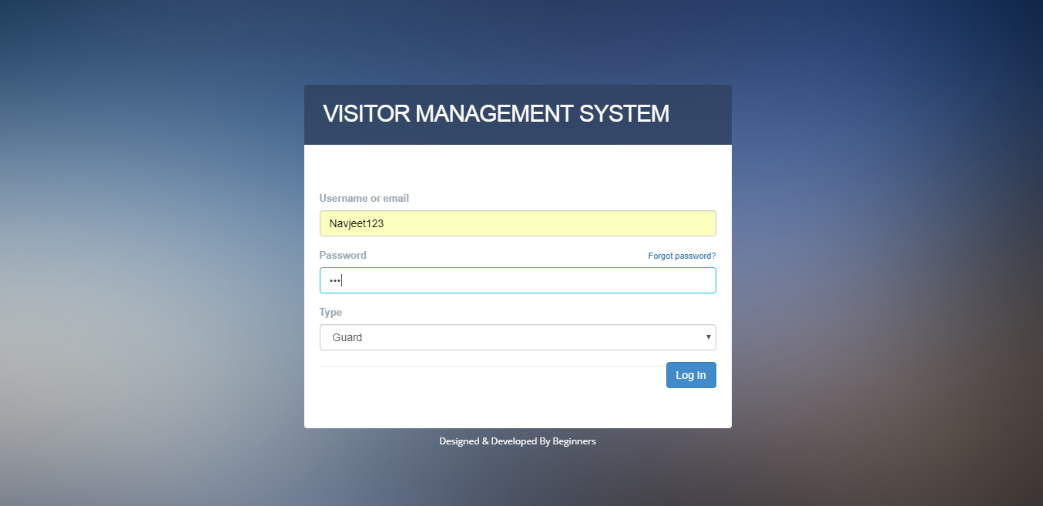

**Login Page:** This page is the first page which ask for the username and password of the user . If the username exist in the database then it will give you the access of the software otherwise it will prompt an error .

The logins exist of two types :-

1. Admin/Head of Department Login
2. Security Login ( Each guard has his personal login )

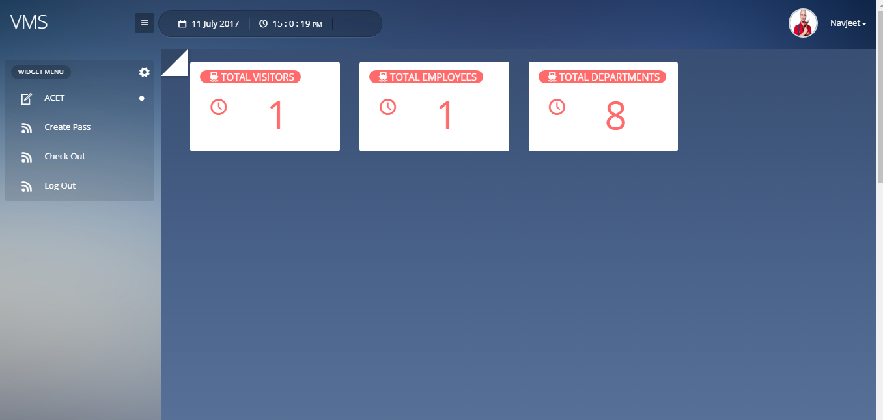

**Guard Page:** This page is the Guard page where Guard can do different jobs like Create pass, Check out etc.

There are different module on which he can jobs.

1. ACET – In this he can check the latest update about the college.
2. Createpass-In this he can create a pass for visitors.
3. Checkout-In this he can update the visitor time when visitor leaves the college.

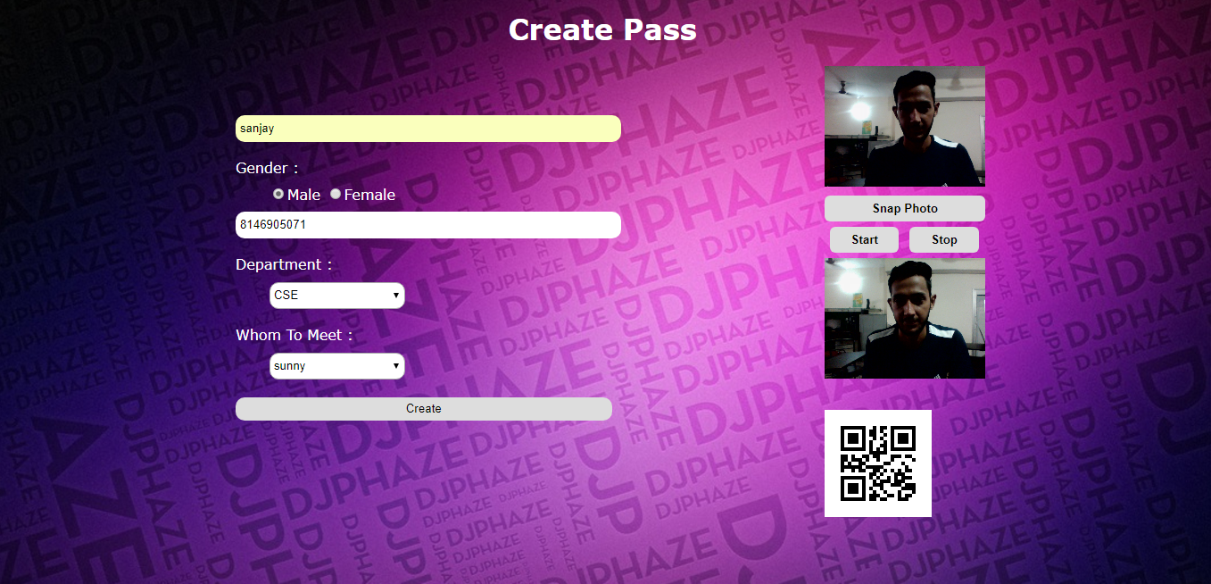

**Create Pass :** This page is used for creating the pass of visitors with live capture image and QR code.

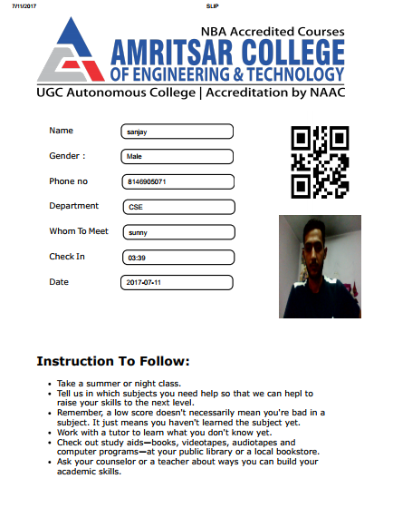

**Slip :** This is the slip which is generated for visitor. So guard will generates these types of slips for our visitor who visits the college.

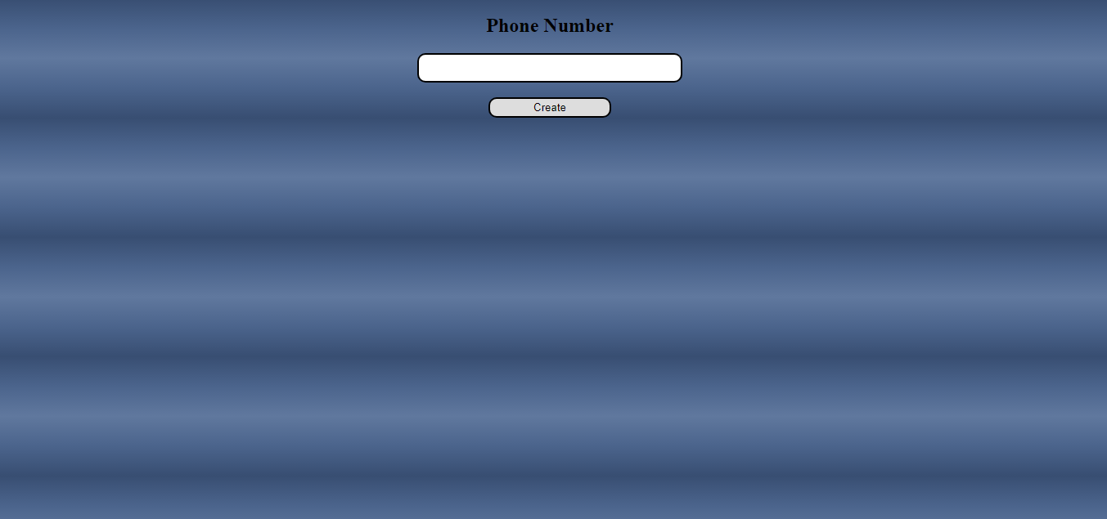

**Check Out:** This is the check out page for visitor. Just by enter the phone number leaving time is automatically update.

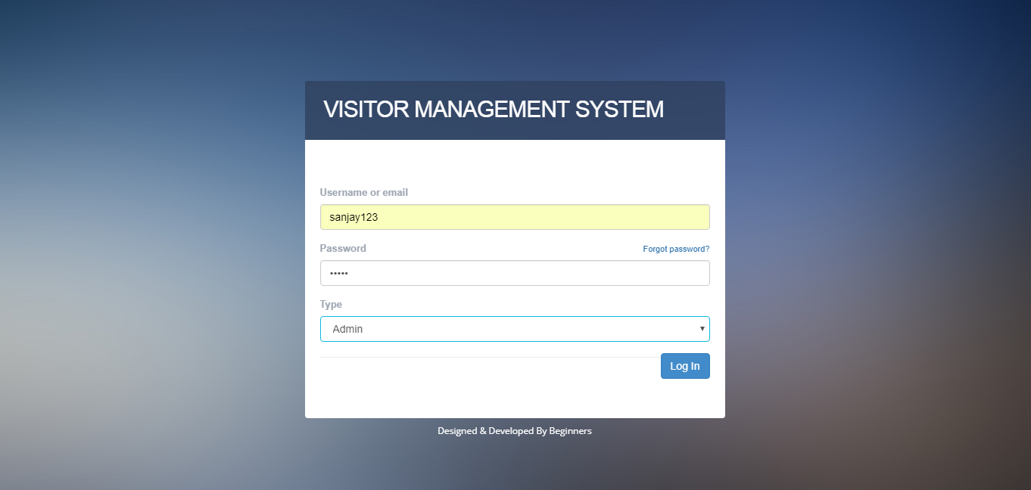

**Admin Login:** This page Login page for Admin by choosing the type Admin in the block which is already registered as a admin.

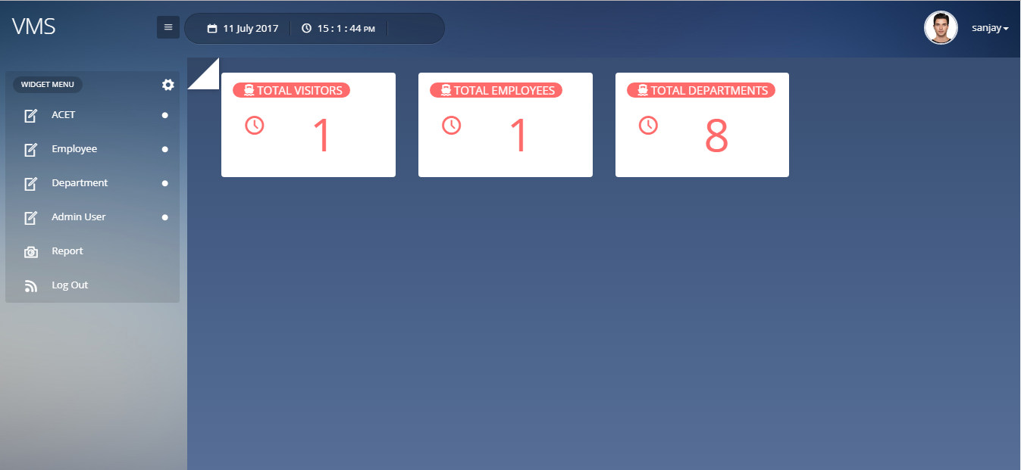

**Admin Screen:** This type dashboard is visible for the admin user. Where he can directly view the total visitors, total department and total employees in the college and can check employee details, visitors details and logins users.

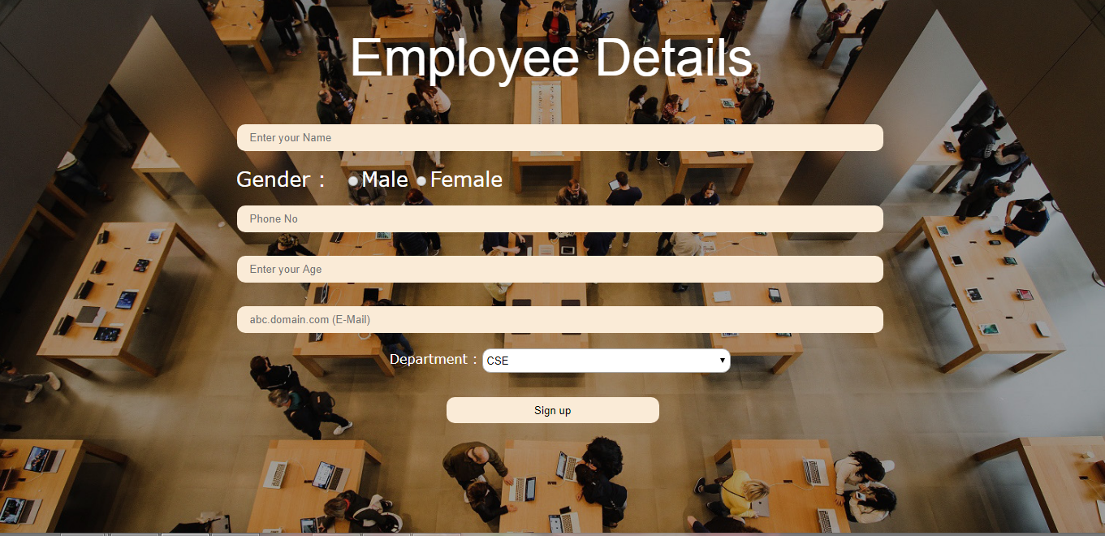

**Add Employee:** This page is used to insert the employee details. By which guard can be able to send mail to the employee when the visitor visits the college.

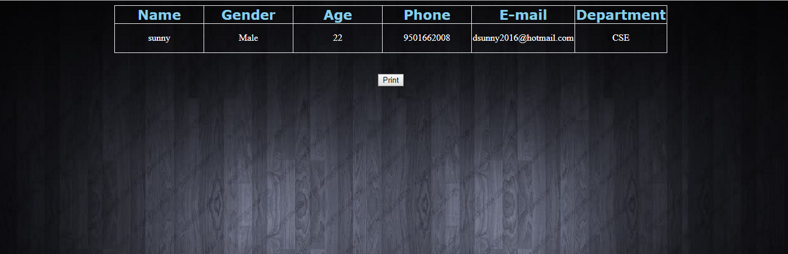

**View Employee:** This page will display the list of all employees in the college.

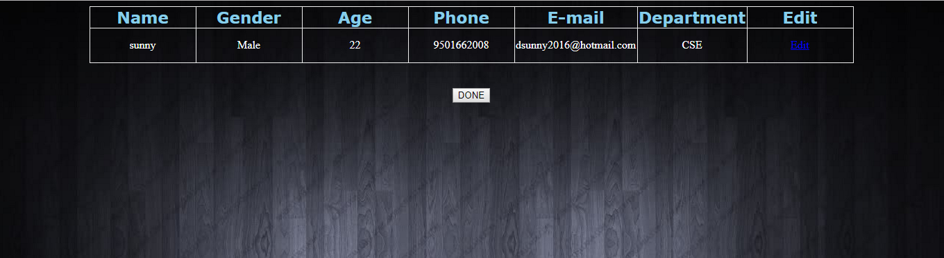

**Edit Employee:** In this page admin can edit the details of the employees in the college.

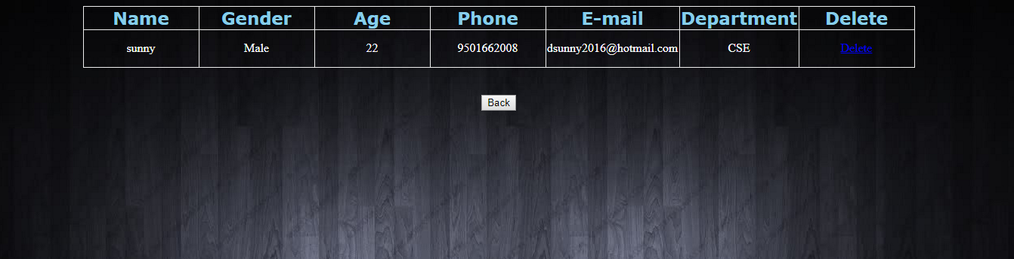

**Delete Employee:** In this page admin can delete the account of employees.

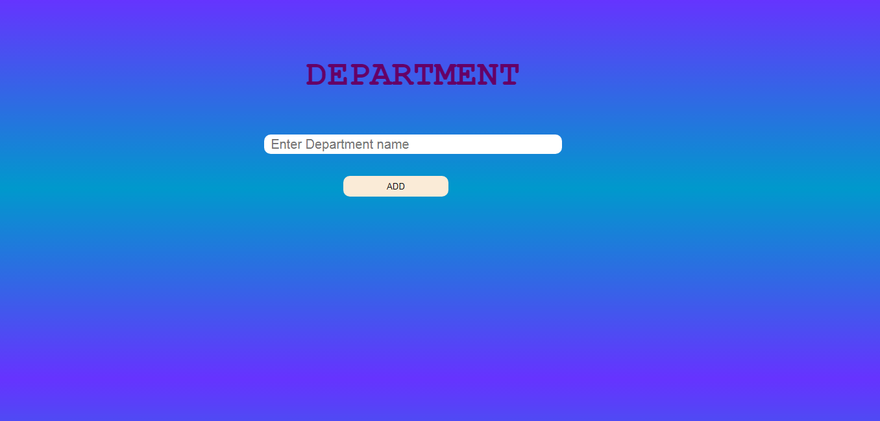

**Insert Department:** This page is used to insert the department in the database.

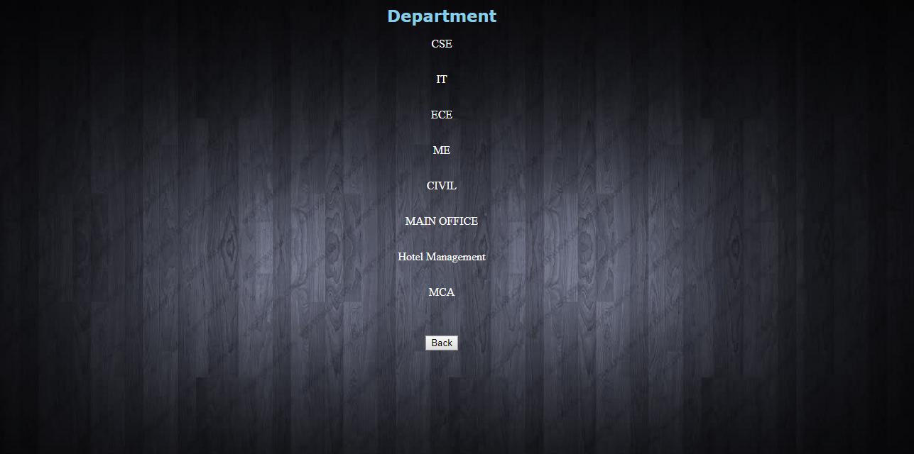

**Display Department:** This page display the details of all department in the college.

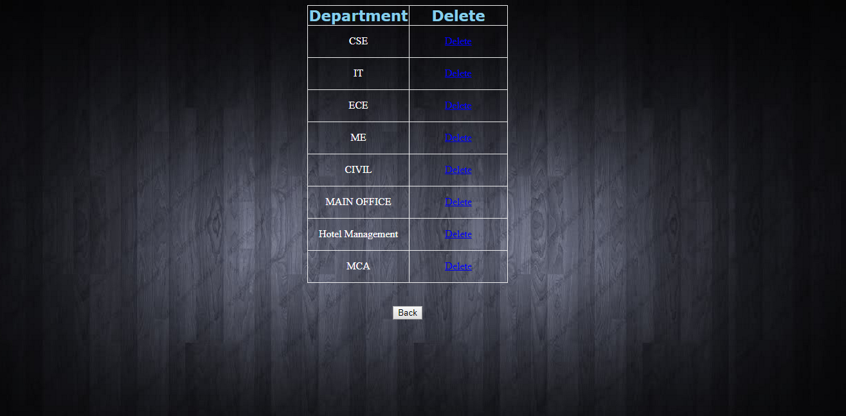

**Delete Department:** In this page admin can delete the department of the college.

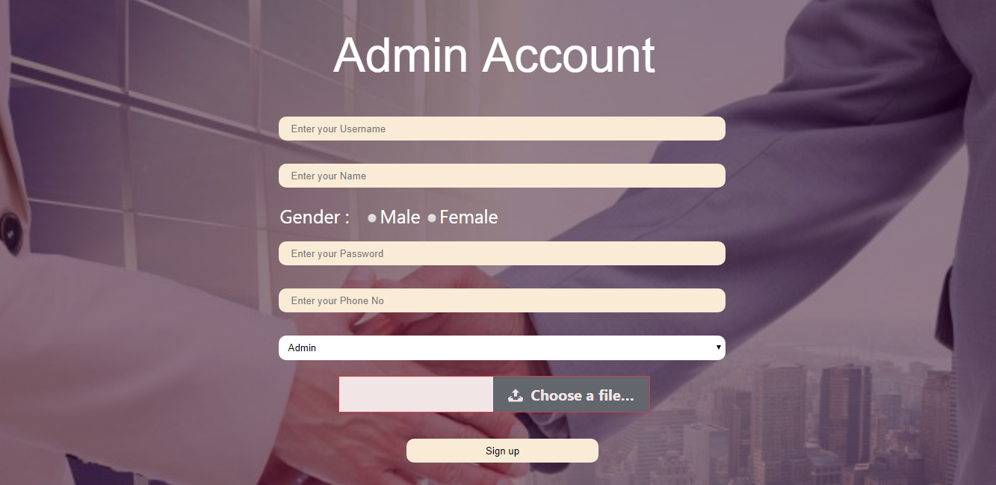

**Insert Admin:** We can use this page for login users. By getting an username and password guard and admin can access their account.

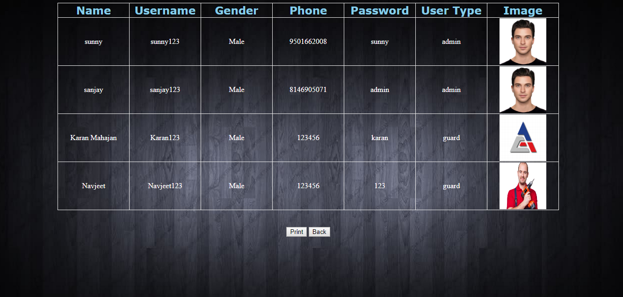

**Display Admin User:** This page will display the all account holder who access this software.

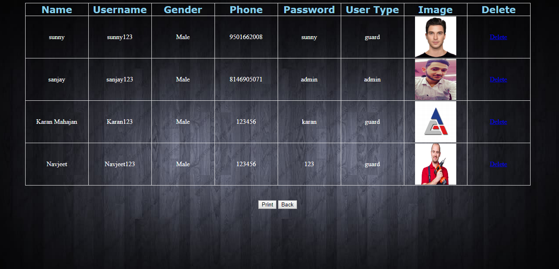

**Delete Admin User:** This page is used to delete the account holder. By which that account holder can’t able to access the software in future.



**Check Report:** This page is used for making the report of all visitors who visit the college by selecting the from date to To date.

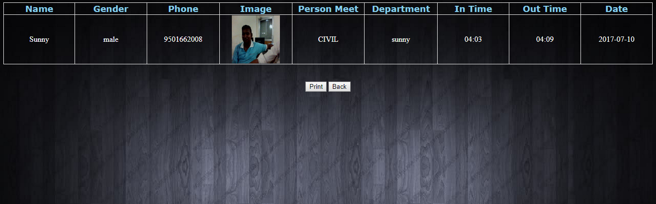

**Report List:** In this page the existed visitor list is display to the admin and he can be able to print the details of all visitors.

**DATABASE DESIGN:**

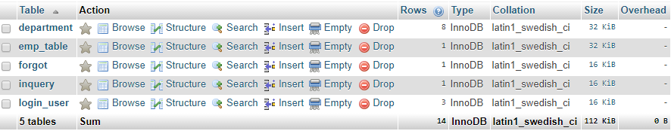

**Fig.1** Projects Table



**Fig.2**  Department Table

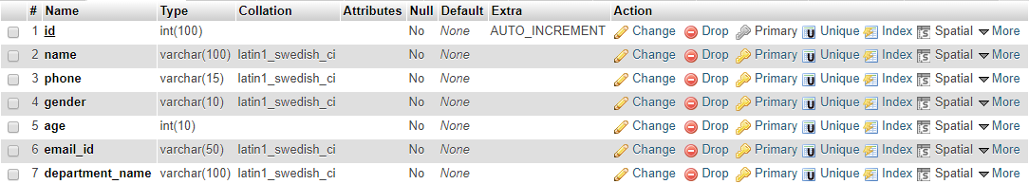

**Fig.3** Employee Table



**Fig.4** Forgot Table

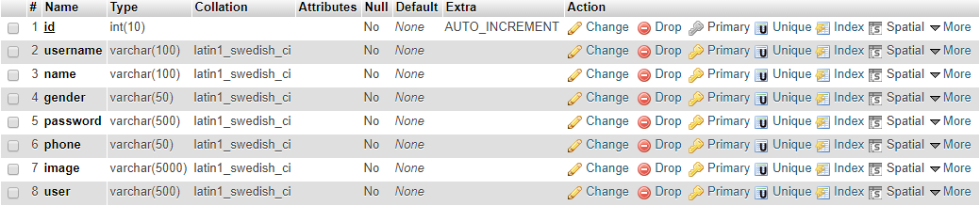

**Fig.5** Login Table

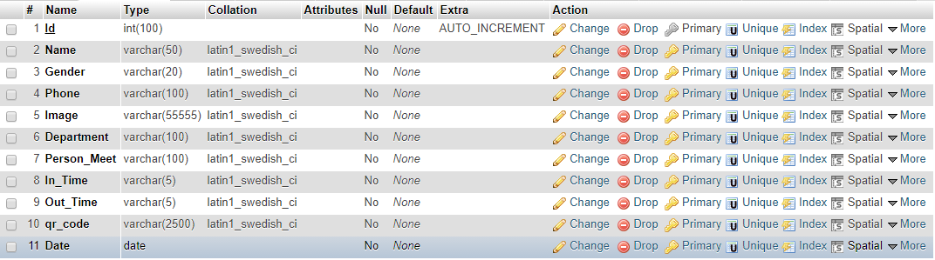

**Fig.6** Inquiry Table

1. **RECOMMENDATION**

This project find a huge scope as it uses concept to facilitate visitor management system. This project introduces manageable and systematic approach of maintaining. We would like to enhance the project with further features. It is generally accepted by high achieving organizations.This project stores the images (jpg) in the folder for the images of visitors, labour, vendors and contractor.

**5. APPENDIX**

This project stores the images (jpg) in the folder for the images of visitors, labour, vendors and

contractor. It is practical that getsyou organized so that you can reduce unnecessary meetings and simply get things done.

XAMPP: Any Operating System Apache MySQL Database PHP Language and PERL.

JPEG: Joint Photographic Experts Group

VMS:- Visitor management System

RAM:- Random Access Memory

HTML: Hyper Text Markup Language

CSS: Cascading Style Sheet

1. **BIBLIOGRAPHY**

<http://www.w3schools.com/php/>

[www.tutorialspoint.com](http://www.tutorialspoint.com)

<http://www.w3schools.com/php/php_ajax_xml.asp>

<http://stackoverflow.com/questions/10711517/turning-error-reporting-off-php>

<http://php.net/manual/en/book.errorfunc.php>